Pencil

User Manual

Version 1.0

Moscow, 2025

# Preface

This manual intends to explain how to use pencil ‑ an implement for drawing, writing, and/or technical drawing.

## Who should read this manual

This manual is designed for people starting from 15 years old who want to learn how to use pencil for drawing and/or writing.

Note:

To use pencil to draw and/or write you must possess the skill of drawing and/or writing correspondingly. The purpose of this manual is merely to explain to you the most important aspects of using pencil, not teach you how to draw or write.

## Additional implements

Pencil can be used on a wide variety of surfaces (e.g. walls, table tops) although using paper is the most common ‑ it can be almost any paper of your choice (notebook, A4 sheet, etc.). However, it is recommended to avoid using coated (“glossy”) paper – it is difficult to draw or write on.

Pencils get blunt so you’ll need something to sharpen them. For that purpose you can use a small knife or a pencil sharpener.

Note:

You won’t need a tool for sharpening if you use a mechanical pencil (types of pencils are explained in section “Overview” of this manual).

A good thing about pencils, in contrast to, for example, pens, is that you can always correct or completely remove what you just wrote or drew ‑ to do that you will need an eraser.

Contents:

Preface 1

Who should read this manual 1

Additional implements 1

Overview 3

Types of pencils 3

Conventional usage 3

Holding a pencil 5

Drawing 5

Writing 6

Technical drawing 6

Sharpening 6

Classic pencil 6

Mechanical pencil 8

Erasing what you drew/wrote 9

Use case 9

Unconventional usage 10

# Overview

## Types of pencils

Pencil has a long, thin shape and is usually made of wood, with a graphite core (lead). Basically, there are two main types of pencils:

* classic pencil (see Figure 1);
* mechanical pencil (see Figure 2).

|  |  |
| --- | --- |
| Figure 1 – Classic pencil. | Figure 2 – Mechanical pencil. |

The key differences between the two types are presented in Table 1 below.

Table 1 – Key differences between the two types of pencils.

| Difference | Classic pencil | Mechanical pencil |
| --- | --- | --- |
| Usage | Classic pencils can be used for all pencil purposes, such as drawing, technical drawing, or writing. | Mechanical pencils are used mostly for technical drawing and writing. These pencils are not designed for art purposes. |
| Sharpening | Classic pencils need to be sharpened every once in a while. For sharpening a knife or a pencil sharpener can be used. Sharpening makes pencil shorter every time so eventually a classic pencil has to be replaced with a new one. | Mechanical pencils do not need sharpening. A special mechanism is used to push the core (lead) out of the body with a press of a button. Leads are replaceable so you don’t need to buy a new pencil when the lead’s all used up. |
| Eraser attached | Classic pencils often have an eraser attached to their top so you can easily correct what you just drew or wrote. | Mechanical pencils do not have eraser attached, instead, there is a button by pressing on which you can push the core (lead) out of the body of the pencil. |

## Conventional usage

Pencil is mostly used for the following purposes:

* Drawing;
* Writing;
* Technical drawing.

Click on an item to jump to the corresponding section of this manual (if you are using the Word version of the manual, hold CTRL key while clicking).

Note:

There are also a number of unconventional uses of pencil, see section “Unconventional usage” for some examples.

### Drawing

Drawing is an activity of creating pictures with a pen or pencil. Since this manual is about using pencil we'll stick to the latter. For drawing mostly classic pencils are used – with a classic pencil you can draw sharp lines and create fuzzy shadings. An example of pencil drawing is Figure 3 below.

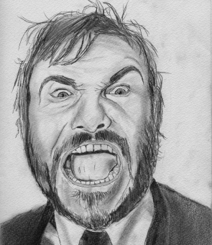

Figure 3 – Drawing made with a pencil.

### Writing

For writing you can use any pencil that suits you best. As mentioned before, the good thing about pencils is that you can easily correct or erase what you just wrote by using an eraser which is often attached to the top of the pencil (that is, if you use a classic pencil). An example of what pencil handwriting can look like is given on Figure 4 below.

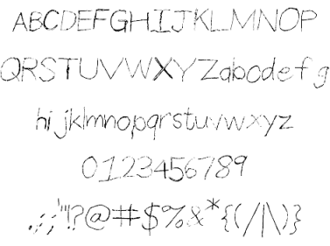

Figure 4 – Representation of pencil handwriting.

### Technical drawing

Technical drawing, or drafting, is a type of drawing that is to represent in detail how something will be constructed. It is used in engineering and requires sharpness – mechanical pencils are most suitable here. An example of a draft is Figure 5 below.

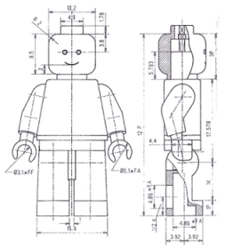

Figure 5 – Robot scheme.

# Holding a pencil

There are many ways you can hold a pencil, however, basically, the way you should hold your pencil depends on what you use it for. Click on an item below to jump to the corresponding section of this manual (if you are using the Word version of the manual, hold CTRL key while clicking):

* Drawing;
* Writing;
* Technical drawing.

## Drawing

Pencil should lie on your four fingers pressed with your thumb (see Figure 6 below), thus, you can emphasize your wrist, not just fingers, which is essential for good drawing.

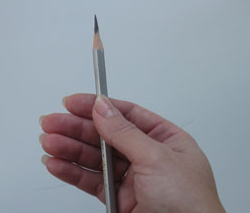

Figure 6 – Holding a pencil for drawing.

## Writing

The grip used to hold or a pencil for writing is the most common ‑ it is a so called tripod grip. The pencil is held with three fingers (index finger, middle finger, and thumb). The closer your fingers to the tip of the pencil, the more control you have (see Figure 7 below).

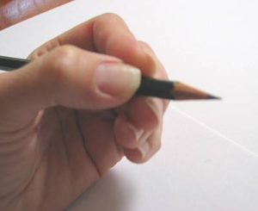

Figure 7 – A tripod grip.

## Technical drawing

Creating a draft requires different types of pencil grip as you will likely use a ruler as well as stencil and/or handwriting. For a quick start, you can use the drawing grip (see section “Drawing”) when using a ruler and the tripod grip (see section “Writing”) when making notes and labels in your draft.

# Sharpening

If lines or letters that you make with your pencil become fuzzy that means that your pencil needs sharpening or, in case of a mechanical pencil, some of the core needs to be pushed out. Depending on the type of pencil you use click on an item below (if you are using the Word version of the manual, hold CTRL key while clicking):

* Classic pencil;
* Mechanical pencil.

## Classic pencil

The way you sharp a pencil depends on what sharpening tool you use (see the list below ‑ if you are using the Word version of the manual, hold CTRL key while clicking):

* Sharpening with a knife;
* Sharpening with a pencil sharpener

### Sharpening with a knife

To sharpen your pencil with a knife use the following instruction.

1. Take the pencil with your non-dominant hand.
2. Take a knife with your dominant hand.
3. Peel the pencil tip with the knife until the tip is sharp (see Figure 8).

Warning!

To not harm yourself point the pencil tip and the knife away from you

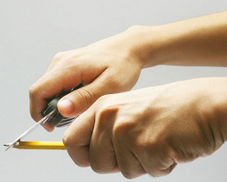

Figure 8 – Sharpening pencil with a knife.

### Sharpening with a pencil sharpener

The procedure of sharpening a pencil with a pencil sharpener depends on what type of pencil sharpener you are using. There are three main types of pencil sharpener. To learn how to sharpen your pencil with a pencil sharpener click on a corresponding item below (if you are using the Word version of the manual, hold CTRL key while clicking):

* Manual pencil sharpener with no hand crank;
* Manual pencil sharpener with hand crank;
* Electrical pencil sharpener.

#### Manual pencil sharpener with no hand crank

To sharpen your pencil insert the tip of the pencil into the opening of the pencil sharpener and rotate the shaft of the pencil against the edge of the blade until the tip of the pencil is sharp. That is, if the opening of the pencil sharpener points at you the rotation is clockwise (see Figure 9 below).

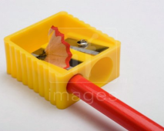

Figure 9 - Manual pencil sharpener with no hand crank. Pencil shaft must be rotated clockwise.

#### Manual pencil sharpener with hand crank

To sharpen your pencil insert the tip of the pencil into the opening of the pencil sharpener and rotate the crank until the pencil tip is sharp (see Figure 10 below).

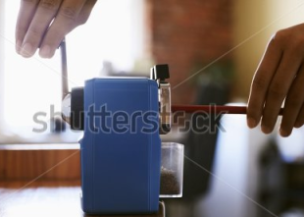

Figure 10 - Manual pencil sharpener with hand crank.

#### Electrical pencil sharpener

To sharpen your pencil simply insert the tip of the pencil into the opening of the pencil sharpener. The process will begin automatically. Hold your pencil in the sharpener until its tip is sharp.

Note:

If your electric sharpener doesn’t work, depending on its type make sure that it’s plugged in or have batteries installed. In case your electric sharpener works on batteries and they are installed and it still doesn’t work, replace the batteries.

## Mechanical pencil

Mechanical pencils do not need sharpening. Instead, to make a mechanical pencil write again simply press the button on top of it pointing the tip of the pencil down – the core (lead) will be pushed out of the body of the pencil for several millimeters. If there is no core left insert a new core – use the following procedure to do that.

1. Press the button on top of the pencil pointing the tip of the pencil up (for example, you can hold the pencil vertically in your fist pressing it against a table top).
2. Keeping the tip of the pencil open, with your other hand take a new core and insert it in the opening on the tip of the pencil.

# Erasing what you drew/wrote

If you are not satisfied with what you just drew or wrote you can always correct or erase it. To do this you will need an eraser (a typical eraser is presented on Figure 11). Luckily many pencils have an eraser attached to their top (see Figure 12) so you don’t have to go far to get one.

|  |  |
| --- | --- |
| Figure 11 – Typical eraser. | Figure 12 – Pencil with an eraser attached. |

To remove something written or drawn in pencil, use the following procedure.

1. Slightly press the eraser against the place on the paper where unwanted drawing or writing is.
2. Rub slowly until unwanted content is removed from the paper.

# Use case

This section contains a typical scenario of using pencil.

1. Decide on what you need a pencil for (see section “Types of pencils”) and choose your pencil correspondingly.
2. Check if your pencil is able to draw sharp lines. If the lines are fuzzy, sharpen your pencil (see section “Sharpening”).
3. Hold your pencil properly (see section “Holding a pencil”).
4. Slightly push the tip of the pencil against the paper and draw a line or write a text.
5. If you are not satisfied with what you created use an eraser (see section “Erasing what you drew/wrote”)

# Unconventional usage

There are a number of unconventional uses of pencil that you may find interesting. Here are some of them.

* Pencil can be used as a pointer.
* You can use pencil to stir sugar in coffee or tea.
* With a pencil you can scratch your own back.
* You can gnaw pencil’s top or shaft to calm your nerves.

The list can be endless – feel free to invent your own way of unconventional pencil use.

# This page is intentionally left blank