How to Create a Pivot Table in Excel 1

Intro 1

Creating a pivot table 1

Configuring a pivot table 2

Access To TicketFlow 4

# How to Create a Pivot Table in Excel

## Intro

Pivot table is a powerful tool to analyze table data. With pivot tables you can create reports that are both human- and machine-readable.

## Creating a pivot table

To create a pivot table, follow these steps.

1. Select the cells you want to add to your pivot table (see the screenshot below).

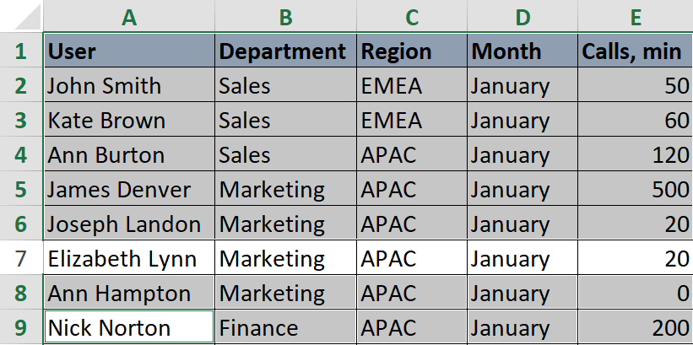

1. In the ribbon select the **INSERT** tab (see the screenshot below).

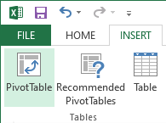

1. Click **PivotTable**.

The following dialog will appear.

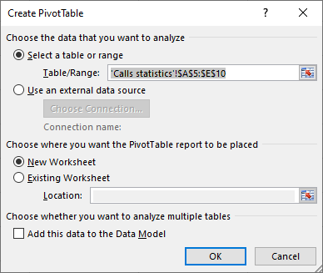

1. In section **Choose the data that you want to analyze** select **Select a table or range**.
2. In the **Table/Range** field check the cell range.
3. In section **Choose where you want the PivotTable report to be placed** set the radio button to:
   * **New Worksheet** – to insert your table into a new Excel sheet;
   * **Existing Worksheet** – to add the pivot table to an existing Excel worksheet (in this case set the position of the pivot table in the **Location** field).

## Configuring a pivot table

To configure your pivot table, use the **PivotTable Fields** panel (by default it appears on the right of the screen – you can drag it closer to the pivot table for convenience), see the screenshot below.

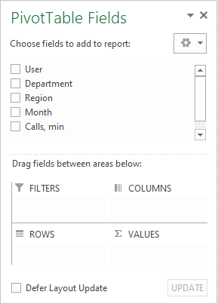

1. Check the checkboxes next to the fields you want to add to your pivot table (see the screenshot below).

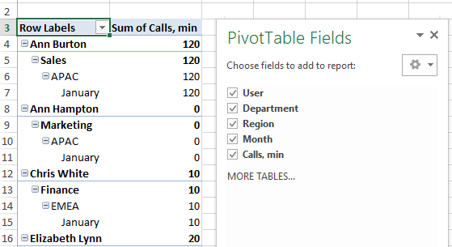

* Alphabetical cells will be added as row labels in a single column.
* Numerical cells will be added as values with a total value on bottom.

1. To apply a filter, drag a field or fields from the **Choose field to add to report** list to the **FILTERS** section (see the screenshot below).

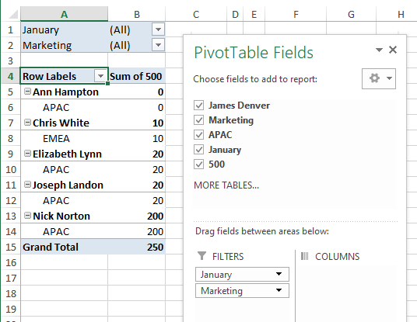

1. To add columns to the pivot table, drag a column name or names to **COLUMNS** section (see the screenshot below).

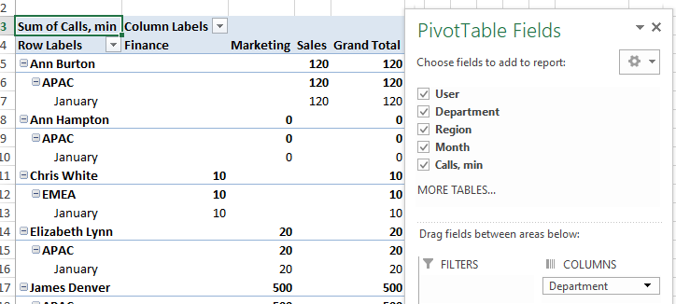

# Access To TicketFlow

Dear colleagues!

As you all know, we are no longer using **TicketFlow** for creating new tickets as we moved to **SmartTicketing**. However, **TicketFlow** still contains much valuable data that was not migrated to **SmartTicketing**. All service desk specialists who worked with **TicketFlow** before retain read-only access with their Windows credentials. For newcomers access to **TicketFlow** is denied by default. To gain that access a procedure called **Access To TicketFlow** must be applied to their accounts. To do this, service desk specialists who have no access to **TicketFlow** when it’s required to do their job must contact our system administrator via an email. Please include **"Access To TicketFlow"** in the email subject.